caAdapter 4.3
Installation Guide

 |   Center for Biomedical Informatics and Information Technology


This is a U.S. Government work. April 24, 2009

Credits and Resources
caAdapter Development and Management Teams
Development | Quality Assurance | Documentation | Project and Product Management
Eugene Wang² | Jyothsna Chilukuri² | Carolyn Kelley Klinger³ | Sichen Lu¹
Ki Sung Um² |  |  | Anand Basu¹
Ye Wu² |  |  | Christo Andonyadis¹
 |  |  | Sharon Gaheen²
- National Cancer Institute Center for Biomedical Informatics and Information Technology (NCI CBIIT) |  | - Science Application International Corporation (SAIC) | - Lockheed Martin Management System Designers

List
caAdapter Users Discussion Forum | https://list.nih.gov/archives/caadapter_users-l.html

Application Support
Application Support | http://ncicbsupport.nci.nih.gov/sw/  Telephone: 301-451-4384  Toll free: 888-478-4423

Contents
About This Guide 1
Purpose 1
About caAdapter 1
Topics Covered 2
Additional References 2
Text Conventions Used 3
Chapter 1 Preparing to Install caAdapter 4
caAdapter 4.3 Tested Platforms 4
caAdapter Software Requirements 5
Adding the JAVA_HOME Variable 6
Ant Required for Source Distribution 7
Adding the ANT_HOME Variable 7
Chapter 2 Downloading and Installing caAdapter 8
Upgrading to caAdapter 4.3 from Previous caAdapter Versions 8
Downloading caAdapter 8
Installing caAdapter 9
Installing the Source and Binary Distributions 9
Installing the Windows Distribution 10
Chapter 3 Verifying Installation 11
Verifying the Binary Installation 11
Verifying the Source Installation 11
Building the Web Service Module 12
Verifying the Windows Installation 13
Verifying Application Resources 13
Understanding HL7 Specification Files 13
Loading HL7 Normative Edition Artifacts 14
Registering HL7 Normative Edition Artifacts 17
Index 18

About This Guide
This section introduces you to the caAdapter 4.3 Installation Guide. Topics in this section include
- Purpose on this page
- About caAdapter on this page
- Topics Covered on page 2
- Additional References on page 2
- Text Conventions Used on page 3

Purpose
This installation guide provides information about supported configurations, installing, and validating the installation of caAdapter 4.3.

About caAdapter
caAdapter (http://trials.nci.nih.gov/projects/infrastructureProject/caAdapter) consists of several components that, via messaging standards, support data sharing at CBIIT (http://ncicb.nci.nih.gov) and/or cancer centers as part of the cancer Biomedical Informatics Grid (caBIG) (http://caBIG.nci.nih.gov) solution. The components include a core engine for building, parsing, and validating HL7 V3 messages via an API or web service, and a mapping tool for providing mapping and transformation services using an assortment of messaging standards or formats such as HL7 V2 and V3 and object and data models.
The caAdapter core engine is an open source toolkit for building, parsing and validating HL7 V3 messages from source clinical systems to promote data exchange in an international, standards-based messaging format. The core engine is a messaging framework that is based on an object-oriented data model, the HL7 RIM, and a set of V3 defined data types. This framework enables clinical applications to build and parse HL7 V3 messages based on specific schema definitions and perform structural, vocabulary and schema validation.
caAdapter integrates with CBIIT’s cancer Common Ontologic Representation Environment (caCORE) components (http://ncicb.nci.nih.gov/NCICB/infrastructure). To see how caAdapter fits with the rest of caCORE, see the caCORE Build Process Diagram at https://wiki.nci.nih.gov/x/i5N8. For more information about the caCORE components, visit the CORE wiki (https://wiki.nci.nih.gov/x/BIAe), the caDSR wiki (https://wiki.nci.nih.gov/x/2qSl) and the EVS wiki (https://wiki.nci.nih.gov/x/paSl). caAdapter facilitates data sharing within the common platform needed to build the caBIG network and translational research infrastructure.
caAdapter is an open source application that supports several types of mapping and transformation. It enables analysts and database engineers, who are knowledgeable about HL7, to create a mapping from Comma Separated Value (CSV) clinical data to an equivalent target HL7 V3 XML format. It provides a front end GUI and a back end engine to support specification of file formats, drag-and-drop mapping between source and target, validation of specifications and data, and transformation of actual CSV data into HL7 V3 XML message instances.
Using similar GUI and mapping features, caAdapter also enables HL7 V2 analysts to convert HL7 V2 messages to HL7 V3 mapping capabilities.
For more information about caAdapter, see the caAdapter 4.3 User's Guide.

Topics Covered
If you are new to caAdapter, read this brief overview, which explains what you will find in each chapter of this guide.
- Chapter 1, Preparing to Install caAdapter, on page 4 explains the platforms that caAdapter 4.3 was tested on and required software and environment variable settings.
- Chapter 2, Downloading and Installing caAdapter, on page 8 explains how to download and install each distribution of the software.
- Chapter 3, Verifying Installation, on page 11 explains how to verify that you have correctly installed the binary, source, and Windows distributions of caAdapter, as well as how to acquire the files required to run HL7-related functions.

Additional References
You can find technical documentation for caAdapter at the following location:
http://ncicb.nci.nih.gov/infrastructure/cacore_overview/caadapter/indexContent/docs/caAdapter_Documentation
- caAdapter Core Engine Architecture
- caAdapter Architecture Diagram
- caAdapter Release Notes
- caAdapter User's Guide
- caAdapter Quick Start Mapping Guide
- caAdapter Design Document
- caAdapter Javadocs

Text Conventions Used
This section explains conventions used in this guide. The various typefaces represent interface components, keyboard shortcuts, toolbar buttons, dialog box options, and text that you type.
Convention | Description | Example
Bold | Highlights names of option buttons, check boxes, drop-down menus, menu commands, command buttons, or icons. | Click Search.
URL | Indicates a Web address. | http://domain.com
text in Small Caps | Indicates a keyboard shortcut. | Press Enter.
text in Small Caps + text in Small Caps | Indicates keys that are pressed simultaneously. | Press Shift + Ctrl.
Italics | Highlights references to other documents, sections, figures, and tables. | See Figure 4.5.
Italic boldface monospace type | Represents text that you type. | In the New Subset text box, enter Proprietary Proteins.
Note: | Highlights information of particular importance. | Note: This concept is used throughout this document.
{ } | Surrounds replaceable items. | Replace {last name, first name} with the Principal Investigator’s name.

Preparing to Install caAdapter
Before installing caAdapter, you must confirm that your system platform has sufficient resources, install prerequisite software, and set environment variables.
This chapter includes the following topics:
- caAdapter 4.3 Tested Platforms on this page
- caAdapter Software Requirements on page 5

caAdapter 4.3 Tested Platforms
caAdapter 4.3 has been tested at NCI CBIIT on the following system platforms with the stated resources.

 | NCI CBIIT Windows Server | NCI CBIIT Linux App Server
Model | DELL Optiplex GX270 | HP Proliant ML 330
CPU | 1 x Intel® Pentium™  2.8 GHz | 1 x Intel® Xeon™ Processor 2.80 GHz
Memory | 3.2 GB | 4 GB
Local Disk | System = 40 GB | System = 2 x 36 GB (RAID 1)  Data = 2 x 146 (RAID 1)
Network | 100mb / full duplex | 100mb / full duplex
OS | Windows XP | Red Hat Linux ES 3
Resolution  (Recommended) | 1280 x 1024  1024 x 768 | 1600x1200  1400x1050  1280x960  1280x864
Resolution  (NOT Recommended) | 800 x 600  640 x 480 | 800 x 600  640 x 480
Table 1-1. caAdapter Tested Platforms and Resources

caAdapter Software Requirements
Table 1-2 on page 5 contains detailed information on the software that is required to execute any distribution (binary, source, and Windows) of caAdapter. The versions listed below are in accordance with the NCI CBIIT technology stack. You must visit each site of the third-party software to review the license agreement prior to using that software with caAdapter.
Software | Version | Description/URL | Directory
Java 2 Platform Enterprise Edition (J2EE) or Standard Edition (J2SE) | 1.5.0_04 | The J2SE Software Development Kit (SDK) supports creating J2SE applications.  http://java.sun.com/j2se/ | If your root directory in Windows is C:\, then install to the C:\jdk1.5.0_04 Java home directory.
JGraph | 5.10.1 | JGraph is an open source Java graph library for the visualization and layout of graphs.  http://www.jgraph.com/downloads.html | Copy jgraph.jar to caAdapter lib directory.
JAXB | 2.0 or later | The JAXB Standard Implementation project at Java.Net delivers a production-quality implementation of the JAXB APIs. This implementation is also the Reference Implementation for the specification.  https://jaxb.dev.java.net | 1. Go to https://jaxb.dev.java.net and click the Download button.  2. Download the binary or source distribution jar file.  3. Follow the instructions on the screen to execute the jar file.  4. Copy jaxb-api.jar and jsr173_1.0_api.jar to the caAdapter lib directory.
Table 1-2. Required Software for All caAdapter Distributions

Adding the JAVA_HOME Variable
For all distributions of caAdapter, verify that the JAVA_HOME environment variable is set and add it to your PATH. Perform the following steps to do this in Windows:
Step | Action
1 | Right-click My Computer > Properties and select the Advanced tab.
2 | Click the Environment Variables button.
3 | JAVA_HOME must be listed in the User variables or System variables section of the dialog box. To add a new variable, click the New button below either section.
4 | In the New User Variable dialog box, add the Variable and Variable Value for your home directory.  Examples:  Variable = JAVA_HOME; Variable Value = C:\jdk1.5.0_04
5 | Find the PATH environment variable, double-click it or click the Edit button and add %JAVA_HOME%\bin to the end of its value. Click all OK buttons to confirm the changes.
6 | To verify that the PATH statement listed in the Environment Variables dialog box includes JAVA_HOME, open a command window (Start > Command Prompt). Type path at the prompt and then press Enter to display your path. For example, C:\jdk1.5.0_04 should be at the end of your path. If you were successful, you can run java anywhere in your system. To verify the java version type java –version at the command prompt.

Ant Required for Source Distribution
If you are installing source code, you must download and install Ant, which is not included with caAdapter. Table 1-3 contains detailed information about Ant and where to download it. The version is in accordance with the NCI CBIIT technology stack.
Software | Version | Description/URL | Example Directory
Ant | 1.6.2 | Apache Ant is a Java-based build tool  http://ant.apache.org/ | If your root directory in Windows is C:\, then install to C:\apache-ant-1.6.2 Ant home directory
Table 1-3. Required Software for caAdapter Source Distribution

Adding the ANT_HOME Variable
Verify that the ANT_HOME environment variable is set and add it to your PATH. Perform the following steps to do this in Windows:
Step | Action
1 | Right click My Computer > Properties and select the Advanced tab.
2 | Click the Environment Variables button.
3 | ANT_HOME must be listed in the User variables or System variables section of the dialog box. To add a new variable, click the New button below either section.
4 | In the New User Variable dialog box, add the Variable and Variable Value for your home directories.  Examples:  Variable = ANT_HOME  Variable Value = C:\apache-ant-1.6.2
5 | Find the PATH environment variable and either double-click it or click the Edit button. Add %ANT_HOME%\bin to the end of its value. Click all OK buttons to confirm the changes.
6 | To verify that the PATH statement listed in the Environment Variables dialog box includes ANT_HOME, open a command window (Start > Command Prompt). Type path at the prompt and then press enter to display your path. For example, C:\apache-ant-1.6.2\bin should be at the end of your path. If you were successful, you can run ant anywhere in your system.

Downloading and Installing caAdapter
This chapter includes the following topics:
- Upgrading to caAdapter 4.3 from Previous caAdapter Versions on this page
- Downloading caAdapter on this page
- Installing caAdapter on page 9

Upgrading to caAdapter 4.3 from Previous caAdapter Versions
caAdapter Users Upgrading to caAdapter 4.3 | All users of previous caAdapter versions are encouraged to upgrade to caAdapter 4.3 to perform HL7 mapping and transformation services.  It is recommended that you uninstall any previous versions of caAdapter before installing caAdapter 4.3.

Downloading caAdapter
Complete the following steps to download caAdapter:
Step | Action
1 | Go to the NCI CBIIT download web site: http://ncicb.nci.nih.gov/download/index.jsp.
2 | Provide your email, name, and institution. Click Enter the Download Area.
3 | Select Download from the caAdapter section.  Check the box labeled Checking this box indicates that you agree to the above terms to indicate agreement to the caAdapter license.
4 | Select the appropriate distribution as listed below and save it to a temporary directory on your computer (for example, C:\temp in Windows). The caAdapter software requires the Health Level 7 (HL7) standards and message specification files to perform HL7 transformations. They are not included with any distribution. These specification files are licensed for HL7 members only. Users are required to register their own membership with HL7 and to obtain these files directly from the HL7 organization at http://www.hl7.org.  - Binary Distribution: The caAdapter binary distribution file contains the binary code, Javadocs, Release Notes, example messages, and licenses.  - Source Distribution: The caAdapter source distribution file contains the source java code, build.xml, Javadocs, Release Notes, readme.txt, example messages, and licenses.  Windows Distribution: The caAdapter windows distribution file contains binary code, Release Notes, readme.txt, example messages, and licenses.
  Binary Zip File Name | Description
  caadapterv4.3_bin.zip | Binary file
  Source Zip File Name | Description
  caadapterv4.3_src.zip | Source file
  Binary Zip File Name | Description
  caadapterv4.3.msi | Windows file

Installing caAdapter
Complete the appropriate steps for your distribution to install caAdapter.

Installing the Source and Binary Distributions
Extract the contents of the caAdapter source or binary distribution zip file to the file system of your computer. For example, if you extract the zip file to C:\temp\MySoftware, then your caAdapter home directory becomes C:\temp\MySoftware\caadapter.
Note: The caadapter directory is created for you during installation of the Windows distribution.
Table 2-4 contains the directory structure after installation.

Installing the Windows Distribution
Double-click the .msi file and follow the instructions provided to complete the installation. Table 2-4 below contains the folder structure after installation.
Directory | Contents
build | Binaries (.class files) (only for source distribution and is created at runtime)
conf | Application configuration files
dist | Contains the .jar file, .war files, and the run.bat file (only for source distribution and is created at runtime)
doc | caAdapter documentation and help system
etc | Important supplementary files (only for source distribution and the its contents will be packed with compiled codes as build the project)
lib | Java libraries and dependencies
hl7_home | HL7 v3 Schema and MIF files. caAdapter 4.3 supports the multi version (normative) of HL7 V3 specification. It is recommended that you create one sub-folder here for each normative.
src | Source code (.java files) (only for source distribution)
workingspace | Default directory where you can save project files. It contains log files and HL7 v3 XML instances. It also contains an examples directory with sample data.
Table 2-4. Directory Structure of caAdapter

Verifying Installation
This chapter includes the following topics. Perform the appropriate processes for your distribution to confirm that the installation was successful.
- Verifying the Binary Installation on this page
- Verifying the Source Installation on this page
- Building the Web Service Module on page 12
- Verifying Application Resources on page 13
- Understanding HL7 Specification Files on page 13

Verifying the Binary Installation
Perform the following steps to launch caAdapter:
Step | Action
1 | In a Command Prompt window, enter cd {home_directory} to go to your home directory (for example, in Windows C:\caadapter).
2 | Enter run.bat. The caAdapter application appears.

Verifying the Source Installation
Perform the following steps to launch caAdapter.
Step | Action
1 | In a Command Prompt window, enter cd {home_directory} to go to your home directory (for example, in Windows C:\caadapter).
2 | Enter ant
3 | Enter cd dist
4 | Enter run.bat  The caAdapter application appears.

Building the Web Service Module
If you installed the source distribution successfully, you can optionally build the caAdapter Web Service module.
To build the caAdapter Web Service module
- Modify build.properties in the caAdapter home directory to include Web Service module. The resulting code should be as follows:
caadapter.release.ws.include=true
- Run ant again. The caAdapterWS.war file is created in the dist folder.
- Copy caAdapterWS.war to the deployment folder of your J2EE web server.
- Launch the caAdapter 4.3 Web Services Management Portal.
For example, if you run the J2EE web server on your local machine on port 8080, you can perform step 4 above using http://localhost:8080/caAdapterWS/. The following dialog box appears.
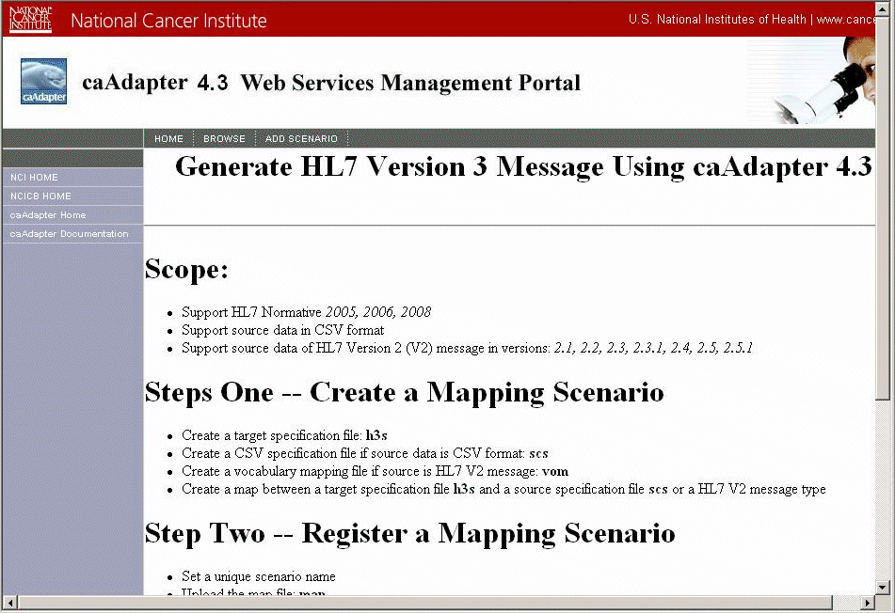
Figure 3-5. Home page of the caAdapter 4.3 Web Services Management Portal

Verifying the Windows Installation
Perform the following steps to launch caAdapter.
Step | Action
1 | Select Start > caAdapter. The caAdapter application appears.

If you can view the caAdapter user interface, your installation was successful. See the caAdapter 4.3 User's Guide for detailed information on using caAdapter.

Verifying Application Resources
After installing caAdapter, edit the modules you would like to use. To do this, open the conf folder and edit caadapter-component.properties as follows.
caadapter.hl7.transformation.activated=true
caadapter.hl7.csv.transformation.activated=true
caadapter.hl7.v2v3.conversion.activated=true
caadapter.web.service.activated=
caadapter.help.menu.activated=true

Understanding HL7 Specification Files
caAdapter 4.3 requires HL7 V3 specification files to transfer a CSV data or HL7 v2 message into a HL7 v3 message.
The following steps describe how to load the HL7 specification file and set up the application configuration file to support multiple HL7 normatives.
To use the caAdapter 4.3, you must get the following three resources from the HL7 organization:
- HL7 V3 MIF file (mif.zip)
- Coreschemas file folder
- Multicacheschemas file folder
The MIF file defines an individual HL7 v3 message. The coreschema file defines HL7 v3 datatypes.
Only HL7 members may access these resources. See www.hl7.org/membership for membership information.
Once you have the HL7 resources, do the following:
- Copy the resources to the file system of your local computer; for example, you can save them to c:\temp\hl7Resource\Normative_yyyy. caAdapter loads the resource files and registers them later.
- Load the resources into caAdapter 4.3. For more information, see Loading HL7 Normative Edition Artifacts, below.

Loading HL7 Normative Edition Artifacts
Do the following to load HL7 v3 normative edition artifacts into caAdapter.
- Select Tools > Load HL7 V3 Normative Edition Artifacts. The Load HL7 V3 Normative Edition Artifacts dialog box appears.
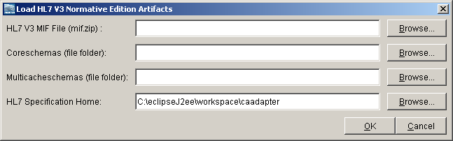
- Click Browse to locate the mif.zip file on your computer. The Select Resource dialog box appears. Select it and click Open.
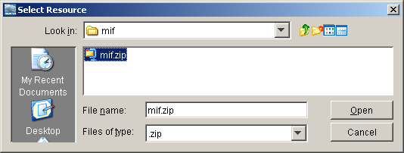
- Click Browse to locate the coreschemas folder on your computer. The Select Resource dialog box appears. Select it and click Open.
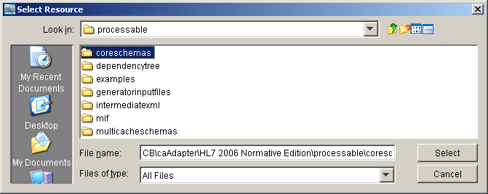
- Click Browse to locate the multicacheschemas folder on your computer. The Select Resource dialog box appears. Select it and click Open.
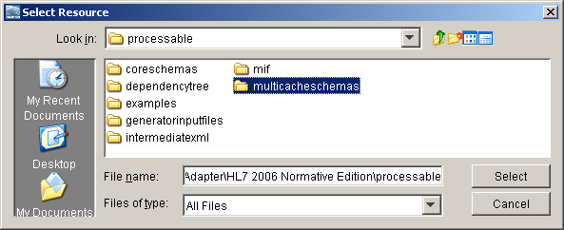
- Click Browse to specify the location of the HL7 Specification Home folder on your computer. This is the location where you will store all HL7 artifacts. Locate this folder within your caAdapter installation folder. The recommended folder name is hl7_home/Normative_yyyy.
The Select Resource dialog box appears. Select it and click Open.
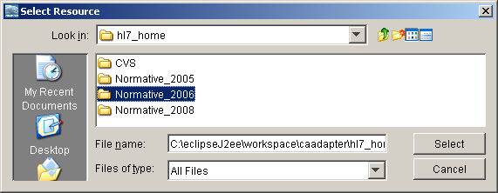
The Load HL7 V3 Normative Edition Artifacts dialog box now lists all of your selections.
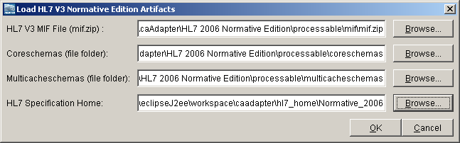
- Click OK.
caAdapter begins loading HL7 v3 artifacts. A confirmation message appears when caAdapter has completed the process. Refer to the screen below for an example of what your file system should look like after the artifacts are loaded.
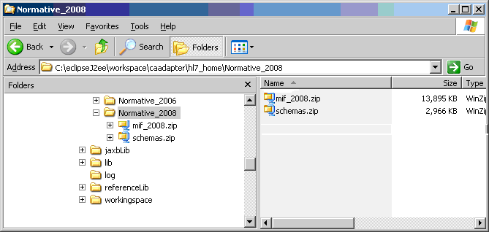

Registering HL7 Normative Edition Artifacts
Since caAdapter supports multiple HL7 normatives, you have the option to load one or more HL7 artifacts (such as year 2005, year 2006, and year 2009). Once the artifacts have been loaded, do the following to register them with caAdapter.
- From the conf folder, open the hl7-normative-setting.xml file.
- Create the normative element within the root element.
<normative copyrightYear="2008" description="Normative 2008">
<mifFile>hl7_home/Normative_2008/mif_2008.zip</mifFile>
<schemaFile>hl7_home/Normative_2008/schemas.zip</schemaFile>
</normative>
- Set the value for the copyrightYear attribute of the normative element. This value should be the same as the copyrightYear value in the HL7 MIF file and must be unique in the application.
- Set the value for the description attribute of the normative element. This is the value that represents the normative element in the HLV V3 Specification dialog box, below.
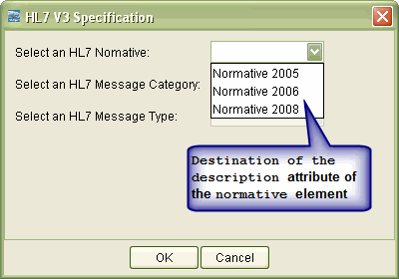
- Create a child element called mifFile for the normative element. Set its value as the path of the MIF file, mif_yyyy.zip, relative your caAdapter home directory.
- Create a child element called schemaFile for the normative element. Set its value as the path of the schema file, schemas.zip, relative your caAdapter home directory.

Index

D
Downloading caAdapter, 8
H
HL7
coreschemas folder, 13
how to get specification files, 13
loading normative edition artifacts, 14
mif.zip, 13
multicacheschemeas folder, 13
registering normative edition artifacts, 17
I
Installing caAdapter
adding the ANT_HOME variable, 7
adding the JAVA_HOME variable, 6
downloading, 8
software requirements, 5
source and binary distributions, 9
tested platforms, 4
verifying the binary installation, 11
verifying the enabling modules, 13
verifying the source installation, 11
verifying the Windows installation, 13
Windows distribution, 10
S
Software requirements
Apache Ant, 7
J2EE, 5
JAXB, 5
JGraph, 5
Source and binary distributions, 9
V
Verifying the binary installation, 11
Verifying the source installation, 11
Verifying the Windows installation, 13
W
Web Service module, building, 12
Windows distribution, 10

